Leaf Spot (Septoria cannabis) life cycle diagram:

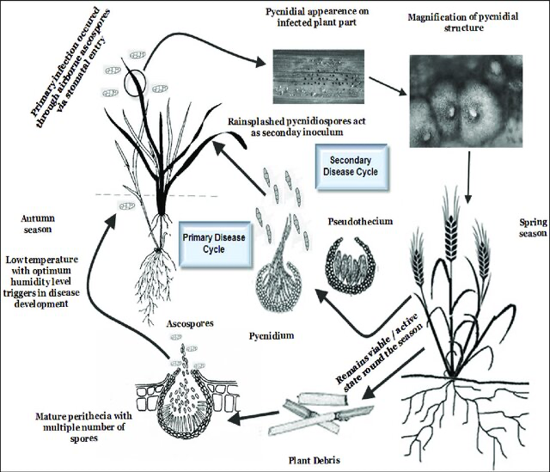
Das, Siddhartha & Pattanayak, Sudeepta & Bhargavi, Boddepalli. (2020). Over view of Septoria Diseases on Different Crops and its Management. International Journal of Agriculture Environment and Biotechnology. 13. 351-370. 10.30954/0974-1712.03.2020.13.

The life cycle of Septoria leaf spot, caused by the fungus Septoria cannabis, includes the following stages:
- Overwintering: The fungal spores survive the winter on infected plant debris, on weeds, and on contaminated seed
- Spore production: When infected tissue is wet, the fungus produces ascospores in perithecia embedded in host leaf tissue and asexual pycnidiospores
- Spore spread: Spores are spread by wind, rain, insects, and other animals.
- Germination: If a film of water is on the leaf, the spore germinates, appressoria forms and penetrates the leaf through stomata or wound in the plant tissue
- Infection: The fungus grows and infects new leaves and twigs.
- Symptoms: Symptoms appear as small, water-soaked areas that enlarge into circular or angular lesions.
- Disease progression: As the fungus grows, the spots enlarge and the leaves turn yellow, wither, and drop.
Structures:
- Ascospore
- Pycnidiospore
- Pycnidia
- Perithecia
- Pseudothecia
- Appressoria
- Mycelium
- Leaf chloroplasts
- Leaf stomata

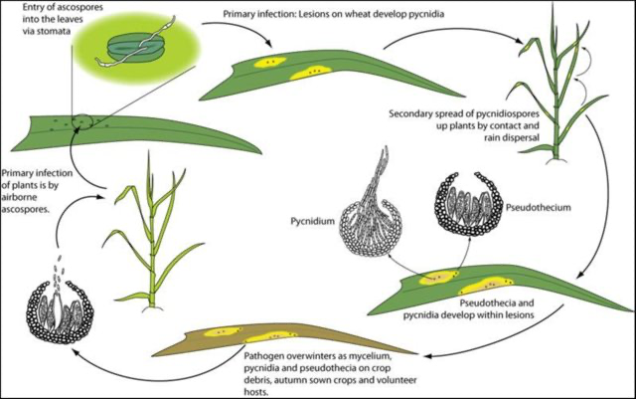
Gohari, Amir. (2015). Identification and functional characterization of putative (a)virulence factors in the fungal wheat pathogen Zymoseptoria tritici.

